Resources to help you with the task

Grammar of Graphics to understand the dimensions of visuals.
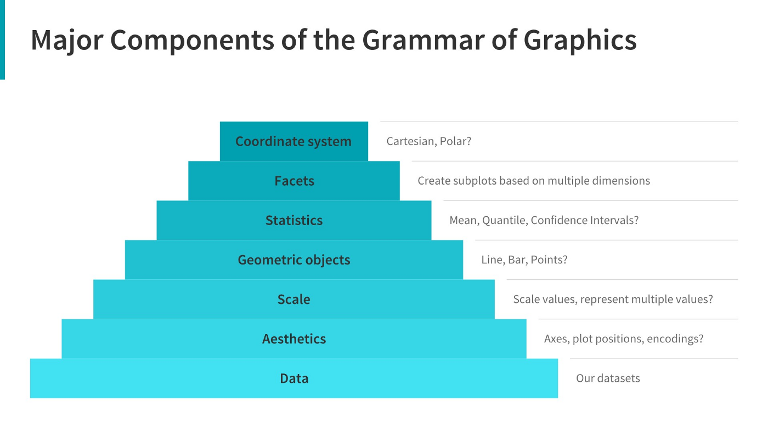

A comprehensive guide to grammar of graphics
https://towardsdatascience.com/a-comprehensive-guide-to-the-grammar-of-graphics-for-effective-visualization-of-multi-dimensional-1f92b4ed4149

How to choose right chart for data visualization
https://www.analyticsvidhya.com/blog/2021/09/how-to-choose-the-right-chart-for-data-visualization/

Choosing right charts based upon need such as Comparison, Distribution, Relationship, and Composition.
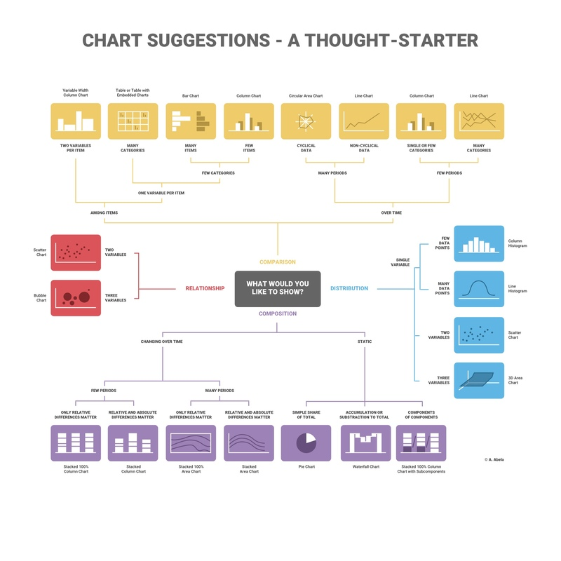
How to choose right chart for your Data
https://infogram.com/page/choose-the-right-chart-data-visualization

Ultimate Guide to choose the right visual
https://towardsdatascience.com/ultimate-guide-to-choosing-the-right-visual-2a77aa8eec08

How to choose the right visualisation
https://chartio.com/learn/charts/how-to-choose-data-visualization/

Which type of graph or chart is good for you
https://www.tableau.com/learn/whitepapers/which-chart-or-graph-is-right-for-you

